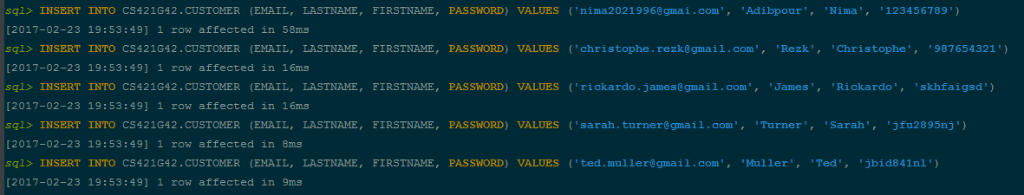Question 3

SELECT \* FROM CUSTOMER;

EMAIL LASTNAME FIRSTNAME PASSWORD

---------------------------------------------------------------------------------------------------- ------------------------------ ------------------------------ ------------------------------

nima2021996@gmai.com Adibpour Nima 123456789

christophe.rezk@gmail.com Rezk Christophe 987654321

rickardo.james@gmail.com James Rickardo skhfaigsd

sarah.turner@gmail.com Turner Sarah jfu2895nj

ted.muller@gmail.com Muller Ted jbid841nl

We have truncated our result to the 5 insert commands asked for in this question. But we have around 100 rows in all tables for the "creativity" question.